CSULB CNSA
Board Meeting Agenda
Sunday, October 2nd 2016 at 5pm
CSULB Nursing Department Room 66

Call to Order at: 5:05
- Opening
- Roll Call
  - Do we have a quorum?
    - 50% plus one of the voting membership
- Guest Announcements:
- Success Stories:
  - Congrats Cristof on getting a job as a mental health worker at La Casa Rehab Center!
- Reports:
Executive Officer and Advisor
  - President—Jalyn Alexander
    - Thank you all for coming tonight
      - Please check-in with Mandy at the end of the meeting if you’re looking to fill an open position
    - Heart Shockers: Upcoming Classes Class Reps please announce classes
      - Jalyn spoke with Nick about the past unprofessional BLS Classes. He was very apologetic and assured us that it would not happen again. If you are attending future BLS Classes, please let Jalyn know how the instructors are because we would not want your education to be affected by poor instructors.
      - 10/22 ACLS 7am-7pm
https://heartshockerseducation.enrollware.com/enroll?a=1&id=1325284
      - 10/23 PALS 7am-7pm
https://heartshockerseducation.enrollware.com/enroll?a=1&id=1325289
      - 10/29 BLS 8am-12pm
https://heartshockerseducation.enrollware.com/enroll?a=1&id=1325316
    - Nursing Apparel
      - Pre-sale will go out this week Class reps announce, ends 10/15
        - The bookstore approved designs will be sent out soon, however a presale list will be distributed if any are interested in getting apparel
      - Voting on a budget will be in two weeks via an online survey
        - See approximate bookstore pricing for each design below
        - We need at least 48 people to sign up PER design for presale in order to get the shirts/sweaters (we are only doing presale and not ordering any extra to sell after); if we do not have 48 people committed to buy by the end of presale, we can extend deadline
      - Winning Designs
        - T-shirt: hand drawn design (estimated pricing: $10/11)
        - Crewneck sweaters: white EKG heart ($18/19)
      - Crewneck Pre-sale: https://docs.google.com/document/d/1lIiVA6NghU19bpf8cLxExVJYZuUCdRmT6TcIv9RV25Q/edit?usp=sharing
      - T-Shirt Pre-sale: https://docs.google.com/document/d/1MiHdvMW8n4jvImkJZyCv4anuTXjUVNmt6XYA1PChWyk/edit?usp=sharing
    - Song-Brown Pipeline Program Tours
      - Friday, November 18th 0900-1430
      - Jordan High School and Cabrillo High School
      - Volunteers Needed
        - Our SON receives the Song-Brown grant from the state, in order to keep the funding we have a duty to reach out to underprivileged Junior High/High School students. Our tour consists of 3 stations: SIM lab activities, Jeopardy game, and a station where stories of overcoming hardships are shared. Our goal is to leave a good impression on them and to let them know that even if you come from hard backgrounds and difficult times, if you’re motivated and dedicated they can also succeed.
        - Help out with the stations (1-2 people per station), if you stay through lunch it will be provided by Dr. Huckaby
      - Email Jalyn if you would like to volunteer
  - Vice President—Maiying Her
    - Honor Cords
      - 100 or more, each cord will be $3.95 each instead of $4.75. Total price for purchase of 100 honor cords with shipping will be $450 as opposed to the price we presented last month of purchasing 30 more at $180
      - Jalyn: “I motion to approve a budget of $450 for honor cords.” So moved.
    - Medals
      - The medal that was voted on the most was the medal with wreath and stars at the top 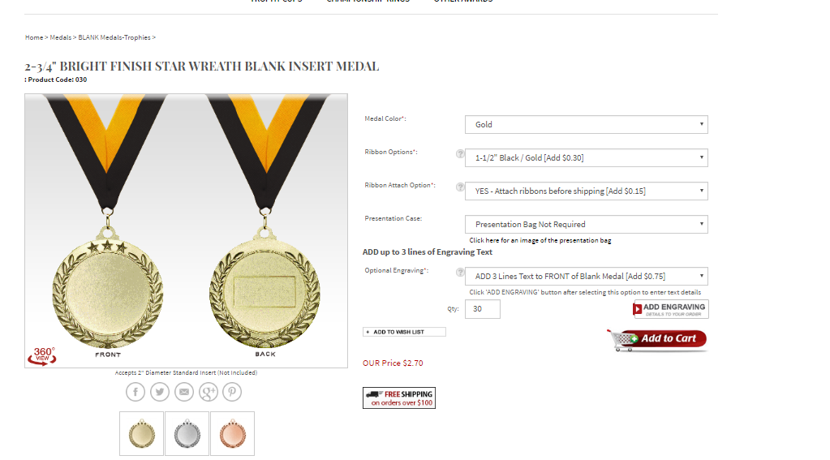
      - Engraving will read CSULB CNSA Distinguished Service Award (approved by CNSA HQ)
      - Attached guidelines: areas that I want to focus on:
        - have to fulfill 18 events in 5 semesters (just 4-5 events per semester) and show continual service each semester (showing that they are going to events each semester)
        - will be given to students on their 5th semester or 4th if their 4th semester falls in May (b/c most students want to walk with their medal)
        - if students want to get their medal by 4th semester, they have to finish all of their 18 events by 4th semester
      - Total is $300 for 100 medals
      - Meeting discussion for guidelines: none
        - Budget proposal – Jalyn “I motion to approve a budget of $300 for the award medals.” So moved.
    - Carolyn Weiss, President for Transgender Business Service
      - Her business is focus on teaching and training staff/ Human Resources about Transgender employees and how to be competent about issues revolving Trans folk
      - Sunday, November 6th at 2:30 pm
        - Opened to everyone—including faculty—in the university. We hope the entire CNSA Board attends!
      - Potluck themed
    - Please make sure you complete a sign up sheet for every event you host.
  - Treasurer—Chrisley Maglanoc
    - Account Balance: $7,030.81
    - Petty Cash: $446.16
  - Secretary—Mandy Perry
    - Room reservations go through Mandy
      - Please turn in room reservation a minimum of three weeks prior to your event
    - Attendance
      - Please make sure to sign in on our attendance sheet.
  - Student Advisor—Brittni Bohan Hope your semester is going great!
  - Cheerleader—Jamie De Luna Hope all is well at work!
  - Mascot—Dr. Anita Fitzgerald Go team! We all enjoy your company!
    - October 5th Wednesday is the annual Dialogue of Caring Sigma Tau event
      - There is a presentation of a difficult topic: Dealing with unexpected death. Then we break down into groups (nursing students, nurses in the community, teachers, etc.) and discuss
      - Students are welcome, the event is at LB Memorial, if interested, contact Jalyn!
  - Faculty Advisor- Sharon Konrad - Words of Wisdom:
    - Stay focused and be very positive about things; be thankful (that we are all well, unlike the patients we care for) and provide kind and empathetic care. As students, don’t get too stressed about all the little tasks because ultimately we are there doing something much bigger than ourselves. Live your lives outside of the hospital: work hard & party hard.
      - Guatemala trip: if interested there are still some spots available, please contact Prof. Konrad
Director and Committee Report
  - Fundraising Director—Hayley Schum
    - Panda Express Fundraiser
      - Will know the total balance in about 5 weeks
    - TV Audience Taping Class reps please announce
      - Steve Harvey’s Funderdome
        - Invention show with voter audience
      - Saturday, October 22nd, 10am-3pm
      - $30 per person
      - Need at least 10 people
      - https://docs.google.com/document/d/1EQt6sByQSi8u1F0NyTEhA7v0s8vCwlTa92ASh65wM60/edit?usp=sharing
    - Pumpkin carving craft night - thoughts? Good amount of interest within the meeting
      - Tentatively Oct. 26. in the evening
        - Location: TBD
      - Budget: $100
        - Budget proposal: Hayley: “I motion to approve a budget of $100 for the pumpkin carving craft night.” So moved.
      - Charge: $5/person (hoping 25 people attend)
      - Sign-ups ahead of time
    - Buffalo Wild Wings fundraiser early November.
    - November mug crafting party
  - Legislative Director—Angelique Pham Welcome to the directorship!
    - The professors are planning on having a skills lab for 450 series before the next semester starts.
      - The professors will set it up but run by the students.
      - A checklist will be used to document the hours.
    - The pharmacy ATI will be changed from the 5th semester to 1st semester.
      - Fitz is fighting this battle; she will make sure that this will not happen. Our pharm class is an introductory course that does not encompass all that the ATI exam tests on (OB meds, ICU meds, etc.). Students opinion: we do not feel prepared to take it 1st semester because we aren’t exposed, comfortable, or knowledgeable about all the medications covered by the ATI book.
    - They are planning on taking out the non proctored ATI 5% from grades.
      - Students are now able to receive a grade higher than a 90% if they score higher on the ATI exam.
    - Faculty may implement charging a lab fee for the undergrad programs for using their disposable equipment in the sim labs but will affect newer semesters.
    - For any contract made with a professor, the student will need to turn in a signed document to their professor for filing.
  - Membership Director—Stephanie Yu
    - If your classmates want to join, please direct them to Stephanie or if you get membership forms/money from your classmates please give them to Stephanie
  - Public Relations Director—Kevin Heng
    - Send Kevin information about your events so he can post them on our social media accounts.
Committee Reports
  - Student Support— Cristof Ronquillo & Michelle Moss Welcome to the directorship!
    - Happy Hour Assistance Sign-up
      - https://docs.google.com/document/d/1Gd5lEkRcCbIS3IFs71L5tTW-UVHkZCfdyJ9lP6YquHM/edit?usp=sharing
      - Will just need to help put everything away once Cristof and Michelle return to class (1:30pm on the Dec 7th date)
      - Pet therapy with one of the Happy Hours?
    - Movie Night
      - Monday, October 17th at 6:30pm or Wednesday 19th
      - Movie Options: Zootopia, Now You See Me 2, Big Hero 6, Home, A Beautiful Mind, etc.
      - Pizza & soda for food
    - Mixer
      - Mexican food
      - Best time for students
        - Nov 2nd or 9th (Wednesdays) 12:00-1:30pm
        - Location: Ballroom?
    - New Student Interviews:
      - Wednesday, October 12th from 0800-1600 (volunteers are signing up on google doc
      - https://docs.google.com/document/d/14diW67lPT7Q3D4kKDmJrd1c6gf93xev8WgAd6MElOB0/edit
      - Providing Bottled water, Nature Valley, cookies, etc.
    - Minute to Win It and Ice Cream Social (churros, ice cream, bananas, strawberries, etc.)
      - Small competition among all the cohorts; 6 reps (1 from each cohort) will compete at a time doing 60 second events
      - November 14th (Monday) at 6:30 pm
      - Budget: $80
        - Proposed budget – Cristof: “I motion to approve a budget of $80 for the Minute to Win It/Ice Cream Social event.” So moved.
    - Weekly Student Success Stories (picture or short video clip) on CNSA’s Facebook Account
      - 4th and/or 5th semester students
        - Every 2 weeks the stories will be posted (posts of words of encouragement )
      - Birthday shout outs (start in January)
  - Mentorship—Dania Al-Itani
    - Care Plan Workshop Discussion
      - October 16th Sunday 12pm
      - There will be a mock-trial patient that we have to care plan for, student’s will split into groups to cover a section of the careplan (labs, patho, meds) and a 4th/5th semester mediator will guide them, fill out the section, and help them critically think about their patient and section (20 minutes). Then they will come together and share their sections with everyone.
  - Professional Growth and Development—Johnathan Tran
    - Mock Interviews week 4th Semester Class Reps please announce
      - Date: October 17th-21st Sunday 12:00pm
      - If you want to practice for the LB Memorial contract or a new grad program, sign up!
        - 5 professors have signed up, 30 minute time slots (12 spots total)
      - Time slot sign-ups to follow next week
  - Community Service—Monique Wood
    - Living Well at the Beach Class reps please announce
      - Monday, October 17th on Campus 11-2pm
      - Blood Pressure and BMI Booth
      - Good opportunity for 1st Semester students to practice Blood Pressure Readings
      - Volunteers needed – (BP part: good for 1st semester students, BMI calculations, and 2 education pieces) https://docs.google.com/document/d/1xAmIpeS0mHPQHyOMmUlQsj2-tUZtW0GijLG2dROjIFc/edit
    - CHOC Event - FULL
      - Tuesday, October 25th
      - Volunteers Needed- https://docs.google.com/document/d/1i47uy5uZf2Gxf3nK3jQcmGy1icYgAAzPOYO27K4RRgo/edit?usp=sharing
    - Alzheimer’s Walk
      - October 29th at the Aquarium of the Pacific (6am call time)
      - Sign-ups TBA, contact Monique
        - Walk the course (separate sign up), encourage friends & family to join the team!
        - Volunteer for registration
    - LB Senior Links Food drive
      - November 4th
      - Note: set up for the food collection will begin mid-October
    - Do Nothing Event – on hold until Spring
      - November 12th
  - Breakthrough to Nursing & Pre-Nursing—Jackie McKenzie & Reya Villegas
    - Planning the next Pre-Nursing workshop
    - Looking into holding a TEAS workshop
      - Goal: introduce ATI TEAS to students, discuss the changes, and provide a quick overview on those changes.
      - CSULB SON will accept new TEAS for Fall admission, it won’t affect those taking it in the Spring.
  - University Involvement—Van Pham
    - Health and Safety Fair
      - Tentative date: Oct 24 @ 10:30-12:30 pm
      - Location: Speaker Platform
      - Attendance is mandatory
    - Castle Food Drive
      - Tentative day: Nov 17
      - Ideas: combine with Beach Pantry (food and toiletries may be donated),
      - Those who use the most non-can items gets bonus points
      - the organization with the most participants receives a bonus
      - We can set up another bin to collect food items
    - Fall Mixer/ Fundraiser
      - Location: TBD
      - Tentative day: Nov 11 @ 4:30-6:30 pm (Veteran's day)
      - Survey -> find optimal time for events for all individuals in groups, not just officers.
      - Each organization needs to submit a list of couple days/times that work for both officers and group members.
- New Business
  - New Student Interviews October 12th
  - Movie Night October 17th
  - Living Well at the Beach October 17th
  - Mock Interviews October 17-21st
  - TV Audience Fundraiser October 22nd
  - Health and Safety Fair October 24th
  - CHOC Event October 25th
  - Pumpkin Carving Craft Night October 26th
  - Alzheimer’s Walk October 29th
  - Carolyn Weiss Event November 6th
- Old Business
  - Successful Events: Panda Express Fundraiser & CHOC Event
  - Tina Talentino-Baldridge - Grad Student Resource List. https://drive.google.com/file/d/0Bze1ZhQu3NgsU0toQ2txMGlIS28/view?usp=sharing
- Goal: Support our fellow officers at their events. We have so many coming up, be part of our CNSA team and help lift each other up!
- Adjournment at: 6:02
- Next Meeting: November 6th at 5pm in Nursing Room 66

