CSULB School of Nursing
CNSA - Board Meeting Agenda
Sunday, October 6th, 2019 at 17:00 Hr
Nursing Department Room 66

- Call to Order at: 17:10
- Welcome CHHSSC Board Member: None
- Quorum: Yes
- Ice Breaker
- Opening
- Success Stories
  - Tina discussed her patient success story.
- Executive Officer & Advisor Reports
  - Faculty Advisor- Tina Tolentino-Baldridge
    - Yoga class
      - Date/time/location TBD-Love will do the poll for date and location on campus. Will take place in December.
      - Dr. Huckabay is looking for 3 volunteers for October 30th from 1730-1930 at the Grand for blood pressure checks

  - President - Dalena Nguyen
    - Health on Wheels-Under 5 Book Drive- 3 books=1 CNSA credit/hour. Put name and cohort on donation and place in the box in the Learning Center. Maximum of 2 donations per semester for credit.
    - T-HELP Wellness Group- Professor Deckers reached out regarding these wellness groups- need volunteers (need to attend all 8 sessions) Every Monday starting Oct7-Nov. 25-1730-1830.
    - Student Interviews: Wednesday, October 23rd 0800-1700-CNSA credit will be given. Will post sign up on BeachBoard

  - Vice President - Jenn Thurber
    - Talent Show Scheduled!
      - It will be on November 22nd from 5pm to 7pm in the USU Auditorium
      - We are looking for talent performers, 7 slots open, winner will receive a gift card, pizza served at the beginning of show!
      - I will be posting a google doc for sign-ups.

  - Secretary - Kourtney Gomez
- There is still time to sign up for the CNSA convention that is next weekend! ($105/$70)

  - Treasurer - Tony Nguyen
    - Account balance of as 10-6-19
      - $10,654.23
    - Updates on merch!
      - The short and long sleeves are good to go.
      - Requesting the last sample for the jacket. Once the jacket arrives, I will be submitting the designs to the company for proofing and request quotes.
    - Short sleeve
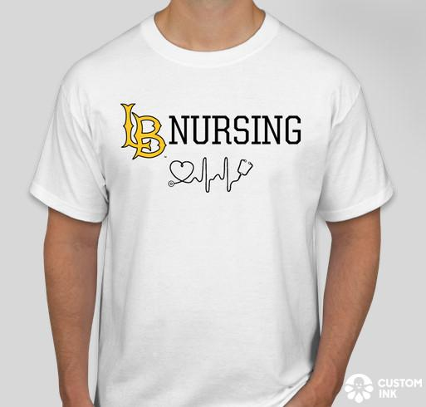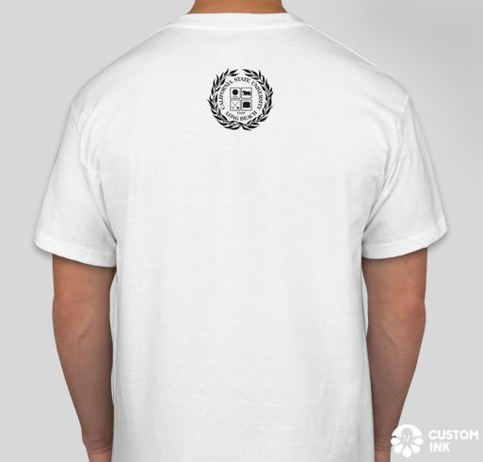
    - Long sleeve
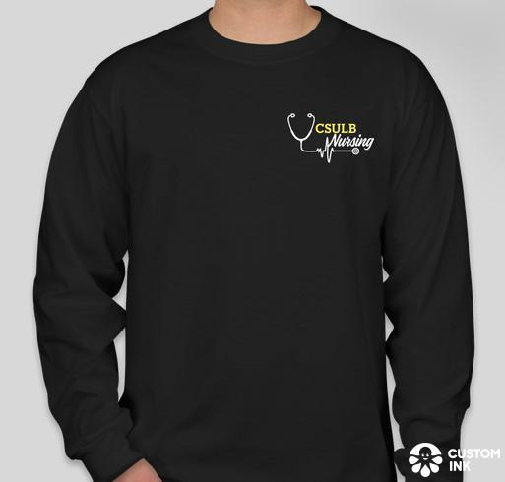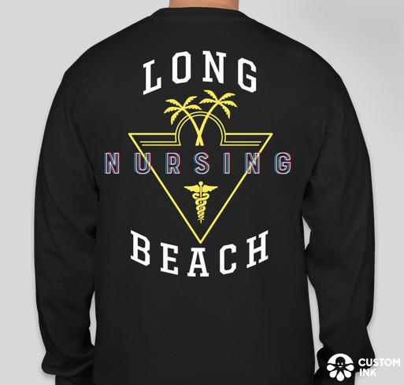
    - Jacket (will not have the Under Armour Logo)
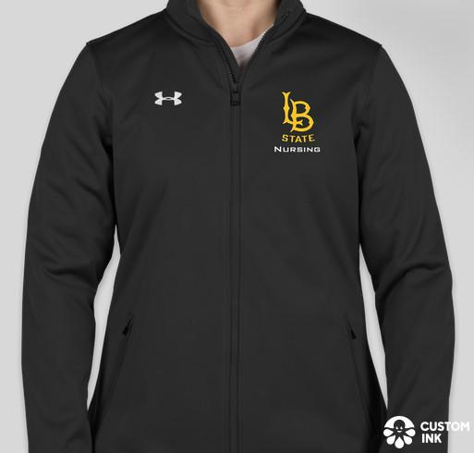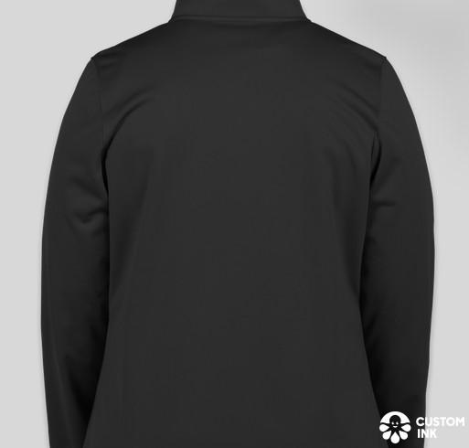
- Director Reports
  - Breakthrough to NRSG Director - Joanne Hwang
    - Pre-Nursing Informational Session
      - Dates: 10/18/19, 10/25/19, 11/01/19 @ 3-5PM-
      - Room TBD
    - Mentoring
      - Working with Abi on making a mentorship with pre-nursing students.
  - Community Service Director - Shyla Coley
    - NAMI Walk
      - Huge success! We had 40 people volunteer and had a great time.
      - We ended up not using the $40 for the BBQ that was previously approved. Everyone brought food and Professor Leever took care of the price of meat. – Want to continue NAMI walk for future years after Professor Leever’s retirement.
    - St. Mary’s Food Bank- November 22 and 8th, 0900-1200
      - Both dates are full! :)
    - VCH Health Fair- November 17th, 1000-1430
      - Link to sign up sheet: https://docs.google.com/document/d/13qp7srHHuhi-Xsmg5hnjS0km3iT9vUDNVOca5GSip3I/edit?usp=sharing
      - Jen G. will be there to help out since she has experience with VCH health fair. Someone will be covering for Dr. Fitzgerald.
      - I will be prioritizing Vietnamese speaking students.
    - Planned parenthood education opportunity- Tina will contact the representative for more information and determine if this event can be held.
    - Long Beach Rescue Mission
    - Alternate list- reminder e-mail before event to confirm attendance or alternates will be contacted to attend the events.

  - Membership Director - Caren Ly
    - CNSA Beachsync
      - Beachsync will be managed by Love and Caren.
        - Love will handle the PR aspect (updating “about” section, posting events and forms, etc.).
        - Caren will handle the membership portion. This includes approving pending membership and emailing non-members and asking if they’d be interested in joining CNSA. This will clear up any confusion for non-members, that is, they do not become members simply by joining the CNSA Beachsync page - must submit application and fee.
        - I created a Google Doc for BeachSync FAQs. Will continue to add to the doc as needed.
  - Mentorship Director - Abigail Loo
    - Care Plan Workshop- livestream the event as well
      - October 22nd, Tuesday from 2:00PM-3:00PM
      - Snacks are provided:)

  - Professional Growth & Development Director - Giovanna Sicolo
    - Leadership at the Beach: Building Bridges & Coalitions- Gio attended, other related events will be posted on BeachBoard.
    - Upcoming events: Resume Workshop and How to get a Job November

  - Public Relation Director - Love Han
    - Sign in sheet for video about your nursing journey is at front-videos will be posted on our website and social media
    - Tentative guest speaker for December meeting - Navy Nursing-May make separate event- discussing with representatives
  - Student Support Director - Philip Cho
    - Happy Hour expansion to 1st, 2nd, 3rd semester students successful, ADN-BSN students partially successful, hard to tell where all ADN-BSN students are.
    - Budget proposals
      - Motion for budget increase from $35 to $50 for Happy Hour weeks of October 14-24- Motion passed for budget increase from $35-$50 for Happy Hour weeks of October 14-24..
      - Motion for budget of $50 for Happy Hour for week of November 11-15- Motion passed for budget increase from $35-$50 for Happy Hour weeks of November 11-15.
      - Motion for increase in Halloween Event budget from approved $80 to $140 (initially approved for $45 on pizza, $20 candies/snacks, $15 drinks); the reason for the request on the increase is to have a buffer in case more food/drinks is needed. Safer to have extra and not go over budget rather than not have enough. Plus I want to budget $10-$15 on having pumpkins for decorations that students may decorate.-Motion passed for budget increase from $80-$140 for Halloween Event.
    - Halloween Social Event underway Fri Oct 25 5:00PM-7:00PM, USU304, tentative reservation made, waiting for Celia’s approval.
  - University Involvement Director - Elaine Tran

      - Blood drive was a success! Over 100 pints of blood. Thanks for those who volunteered.
      - Climathon – October 25-26th
        - Duncan Anderson gallery design departments 1000-2200
        - https://climathon.climate-kic.org/en/long-beach
      - Next meeting: October 9th

- New Business:
  - N/A
- Old Business:
  - N/A
- Adjournment:
  - 1802
- Next Meeting:
  - November 3rd at 1700. Will start at 1600 for travel nurse presentation.

