CSULB School of Nursing
CNSA - Board Meeting Agenda
Sunday, JANUARY 20th, 2019 at 17:00 Hr
Nursing Department Room 66

- Call to Order at: 17:05
- Opening
- Role Call
- Guest Announcements
- Success Stories
Talent Show
    - Thank you to everyone who performed, volunteered, and participated! GIANT shoutout to members of this committee for all the poster-making and organizing and outreach.
    - New student orientation and White Coat ceremony, thank you to all of our amazing volunteers
    - 1218S pinning ceremony. Congrats to our previous boards that graduated!
- Executive Officer & Advisor Reports
- President - Tony Nguyen
Tabletop Banner ($112) + Reusable Tablecloth ($47) (Cheaper than previous table cloth)
      - https://www.4imprint.com/product/147820/Phoenix-Adjustable-Tabletop-Banner
      - https://www.bedbathandbeyond.com/store/product/indoor-outdoor-twill-tablecloth/3309492?categoryId=12142
      - Tabletop Banner- Tony motioned, Katherine seconded, all in favor, no opposed, no abstained, PASSED. Vote on design first week of April.
      - Reusable Tablecloth- Plans to use the school of nursing tablecloth
BLS/ACLS/PALS/EKG
      - Will post a poll on BB to narrow down on the most popular class/package, will have pricings on the poll.
      - Potential class dates will also be on the poll so students can pick the dates that most can attend
Needs to make AWESOME/PROFESSIONAL flyers?
      - Download this FREE Adobe Spark app from our school’s Okta portal
https://e5.onthehub.com/WebStore/ProductsByMajorVersionList.aspx?cmi_mnuMain_child=34109b7e-b838-dd11-abb7-0030485a6b08&cmi_mnuMain=8ecddf42-3b61-e011-971f-0030487d8897&ws=ea1d4692-54e0-de11-baeb-0030487d8896&vsro=8
      - Remember to send me your flyers 3 weeks in advance of your actual event date so I can help you print it out in COLORS
Kaplan NCLEX Prep
      - Kaplan reached out regarding the services they offer
      - Pnina, recent graduate, will be our guest speaker and will come in soon to talk about the different packages they offer if you want more practice.
      - Enter the raffle below for FREE NCLEX Giveaway (Last day February 15th)
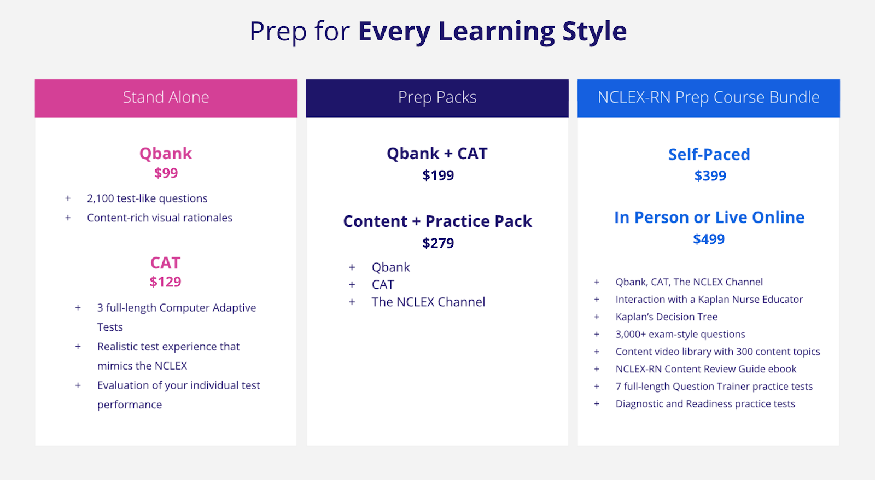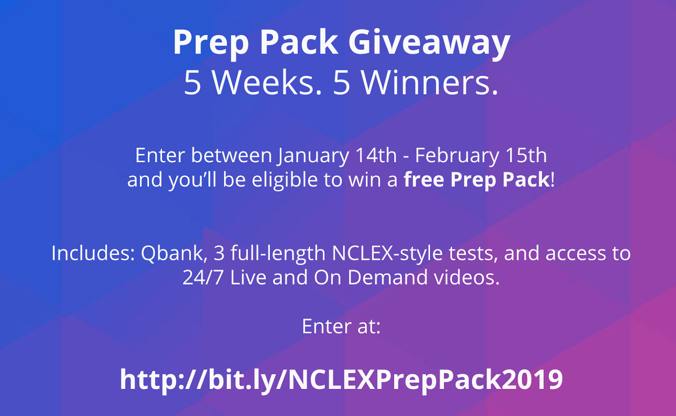

  - Vice President - Farrah Llanes
    - Blood Drive Committee
      - Met today! If interested, email cnsa.vp@gmail.com
      - Dates: Tuesday, 2/19 & Wednesday, 2/20. Time: 8:00AM-6:00PM
      - Location: Ballroom in USU
      - Talking to Celia about tabling reservations, signs, etc. Will advertise and table leading to the event.
    - Hanoi Donations were successful. Prof. Retardo wants to thank us all for our contributions.
    - Nursing Study Sessions were semi-successful.
- 1 attendance on the second study day, but he really appreciated it! Perhaps, just hold the room and no donuts?
- Maybe not buy donuts in the future?
    - Please send me all event sign-up sheets via cnsa.vp@gmail.com within 72 hours of event. I will email you back with a confirmation that I did get the email.
    - Recommend changing the honor cord/medal system to only have awards once a year.
- Will reevaluate how points are given. Happy Hour will no long be worth credit.

  - Secretary - Jenn Thurber
    - THANK YOU FOR TAKING NOTES MAEVE!

  - Treasurer - Florenzo Fejeran
    - No updates

  - Faculty Advisor - Dr. Ketola
    - NSNA Conference April 2nd-7th in Salt Lake City, Utah. Possibly sponsor a couple of students to attend?

  - Student Advisor - Shealyn Engfer
    - No update

  - Mascot - Dr. Fitzgerald
    - VHA health fair on Sunday, March 3rd
      - We will be doing hemoglobin screenings and providing nutritional information
      - Should include some preparation of information and handouts regarding healthy eating, i.e. DM and heart disease. Need Vietnamese and Spanish speakers, but not everyone has to have a second language.
    - Shower project at St. Luke's are:
      - Saturday, January 26
      - Saturday February 23*
      - Saturday, March 23
      - Saturday, April 27
      - Saturday, May 25
*in February I have a Sigma Theta Tau meeting to run at 11, and I will have to leave quite early, so it would be nice to have a veteran there on that day, if possible.

- Director Reports
  - Breakthrough to NRSG Director - Katherine Dawson
    - WOW is Jan 30th and Jan 31st
      - Will be sending out an event sign-up sheet soon and will be advertising on the pre-nursing FB page
      - I motion to pass budget of $30 (assorted snacks from costco and printing) Katherine motioned, Tony seconded, all in favor, no opposed, no abstained, PASSED.
      - Collaborating with blood drive committee???

  - Community Service Director - Maeve Castleberry
    - The Village Clothing Drive was a huge success!
    - St. Luke’s Shower Project
      - 1/26/19, 2/23/19, 3/23/19
    - VHA Health Fair
      - Hemoglobin screenings
      - Sunday 3/3/19
    - Celebration of the Young Child
      - 4/27/19
      - Booth Ideas Welcome!

  - Fundraising Director - Janessa Deleon
    - Christina Limon filed a W9 for Raising Canes. Waiting to follow up with Canes about receiving the funds.
    - Christina is still in the process of completing the W9 for Yalla.

  - Legislative Director - Jen Gidaya
    - Constitution
      - Still awaiting reply from Celia for advice how to fix quorum definition.
      - Certain section needs to be changed. Will update next meeting.
    - Updated Officer forms
      - Need 5 officers to give me their info to be put in the system (bare minimum for operating a club)
      - All new officers must complete an Officer Eligibility form (pls complete if you have not done before) I will be sending out a link later.
      - https://l.messenger.com/l.php?u=https%3A%2F%2Fnam01.safelinks.protection.outlook.com%2F%3Furl%3Dhttps%253A%252F%252Fcsulb.campuslabs.com%252Fengage%252Fsubmitter%252Fform%252Fstart%252F236645%26data%3D02%257C01%257C%257C52157bddca2342346e4208d67be3a3e2%257C84df9e7fe9f640afb435aaaaaaaaaaaa%257C1%257C0%257C636832614964634632%26sdata%3DxEheUlZkhkNUOQ9fq56g0croaPiEjMx1LflfQ02U0x0%253D%26reserved%3D0&h=AT0TnFQxISIQQI2kk0yAJd51RJ0qUOShaRJ8Xc4eGyzHjikH0HlIQsYXLxyAdByxo7UcCwmWRxd4zbHhWQAl8_6yD4luwe2bs_-zEiab_bRKIU_zVQ7c367Ft0unDguDPPHWjIV_NeShU-tuszzmxA

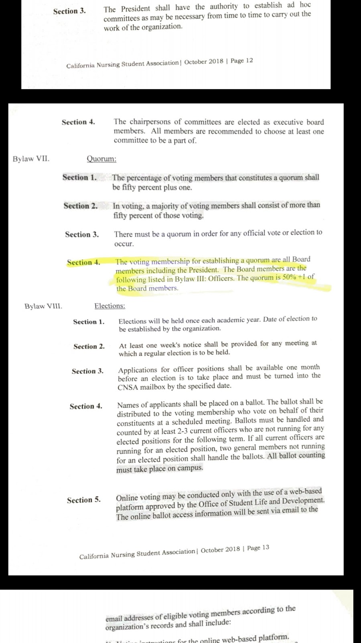
  - Membership Director - Nissa Araque
    - 44 new members from NSO!! ($660)
    - Beachboard Membership list and class list updated

  - Mentorship Director - Adrian Fajardo
    - Mentorship pairing completed (still open for application until 2nd week of school - 2/1/19)
    - More mentors than mentees, some people did not receive a mentee. Emails were sent out for those assigned.

  - Professional Growth & Development Director - Dalena Nguyen
    - Resume Workshop Spring 2019
      - Motion budget of $82 (giftcards, thank you cards, refreshments)
      - Kaelyn motioned, Katherine seconded, all in favor, no opposed, no abstained, PASSED.

  - Public Relation Director - Reyna Bhakta
    - No updates!

  - Student Support Director - Alexandra Cao
    - Happy hours
      - 1/29 11AM-Noon courtyard. Collecting applications for CNSA at happy hour.
      - Thursday 1/31 Happy Hour?

  - University Involvement Director - Kaelyn Miller
    - Helping to coordinate publicity for the blood drive (CHHSSC)
      - Will bring up topic at the meeting this Wednesday
      - Will talk about advertising to the rest of the school
    - Thank you Tony!
      - Will be helping me attend meetings after this month
- New Business:
  - First Day of School!!!!!!!
- Old Business:
  - Talent Show
  - New Student Orientation
  - White Coat Ceremony
  - All were a success
- Adjournment: 17:49
- Next Meeting:
February 10, 2019
Will have to change to second Sunday of each month due to the time conflict with the Army during the first Sundays.

