CSULB School of Nursing
CNSA - Board Meeting Agenda
Sunday, February 9, 2020 at 17:00 Hr
Nursing Department Room 66

- Call to Order at: 1711
- Voting quorum present (50% +1)? Yes
- Success Stories
  - Shyla started her ICU preceptorship.
  - Caren started her Med-Surg preceptorship
  - One student had her first pre-planning day
  - Philip helped change someone’s tires
- Executive Officer & Advisor Report
  - Mentorship Director-Abigail Loo
    - Mentorship Sign-up: If you are a first semester nursing student and interested in a mentor, then sign up today. If have any questions please e-mail Abigail.
https://docs.google.com/spreadsheets/d/1xPORucAcVpR5v_g3GEkMqG6Q0Lr6vjTocvwDh0Gdb7k
  - Faculty Advisor-Dr. Fitzgerald
  - Faculty Advisor-Tina Tolentino-Baldridge
    - Spring Yoga Class with Kelly Ramirez- Will contact Love to make a poll to determine date for members.
    - St. Mary CARE Pantry- Wednesdays and Fridays-priority to fill Friday. Working with Shyla to fill spots.
    - Is pregnant and due June 9th. Congrats Tina!
  - President-Dalena Nguyen
    - Member Feedback Survey: Beachboard>CNSA>Member Feedback- One question asking what you want to see more or less of in CNSA. Please fill out if you would like to provide feedback.
    - Thailand/Cambodia Medical Mission Powerpoints: BeachBoard
    - BLS/ACLS/PALS: March
    - Graduate Interview Volunteers-March 4th and 6th-Dalena will post link for volunteers.
  - Vice President- Jenn Thurber
    - Guest Speaker March 1st Meeting: Connie Merritt: Meeting will start at 4PM. She is a motivational speaker. http://www.conniemerritt.com/
      - Motion budget of $10 for her parking pass-Dr. Fitzgerald will get parking paid for by the University.
  - Secretary-Kourtney Gomez
    - Potential next meeting date for April- April 5th.
    - QPR Certification Course- Will post date/sign-up when available.
    - Mindfulness and Self-Care Class-Will ask Love to get a poll to determine best date and time.
    - CSULB Canned Food Drive-Working with Christina Limon and will post further details when available.
  - Treasurer-Tony Nguyen
    - Account Balance: $10,051.25
    - Merch Pick-Up/Sell Update on Beachboard
  - Breakthrough to NRSG Director-Joanne Hwang
    - Past Event: Week of Welcome-17 sign-ups
    - Pre-Nursing Mentorship Program with Abigail Loo
  - Community Service Director-Shyla Coley
    - Blood Drive
      - Will take place on March 24th and 25th from 0800-1900.
      - Will need volunteers for tabling on: Feb. 26th, March 3rd, 12th, 18th – Credit will be given.
      - One credit will be given/one hour to donate
    - Planned Parenthood Event
      - February 28th 9 AM-1 PM
      - One credit will be given on credit system or two hours will be given if under the hour system.
    - Telemundo Health Fair
      - March 29th 1000-1700-Will get more information from Dr. Fitzgerald.
    - VCH Health Fair-Full
      - February 23rd 1000-1400-Volunteer list full.
    - More St. Mary Dates – Will contact board members to make more dates available.
  - Fundraising Director-Kathy Hoang
    - Possible fundraiser collaboration with HSSA
    - Pieology Fundraiser: TBD
    - Waiting to hear back from Shake Shack
  - Legislative Director-Jasmine Vu
    - Faculty Meeting Feb. 12th- Send any questions or comments for meeting to Jasmine.
  - Membership Director-Caren Ly
    - Membership Application Updated: CNSA Beachboard>Content>Membership
      - Since Mo has retired please give applications to Caren, e-mail contact is at the bottom of application.
    - Honor Cord and Honor Medal Eligibility
      - It is not required to get an honor cord/medal to stay in CNSA.
      - 1st semester students if you would like to receive an honor medal you must do an event every semester starting with your first semester. Trimester students are not required to do events over summer.
    - Event Record: CNSA BeachBoard>Content>Honor Cords & Medals>Event Records
    - New Event Sign-in Option: Paperless, QR code + Google Form- This new sign-in is not required, and is up to the event coordinator if they want to use this option. Text Caren if you would like one for your event.
      - Example:
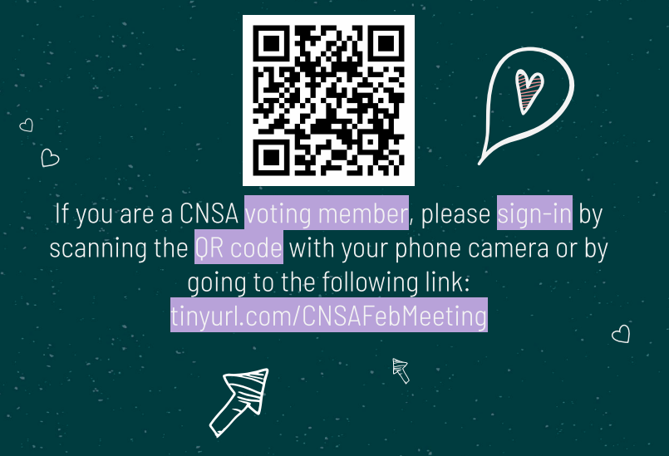
  - Public Relation Director-Love Han
    - Past Event: Ice Skating in January
    - Send ads and polls to Love.
  - Student Support Director-Philip Cho
    - Suggestion - Happy hour events: 1 credit hour for helpers/volunteers, 0.5 credit hour for attendees- Credit will be given.
    - Budget Proposals
      - Motion for Budget of $50 for general snacks/candy for Tuesday/Thursday- Motion passed.
      - Motion for budget of $40 for February 19 (Wednesday) Happy Hour, bagels and coffee-Motion passed.
      - Motion for budget of $40 for March 4 (Wed.) Happy Hour, doughnuts and coffee-Motion passed.
      - Motion for budget of $40 for March 25 (Wed.) Happy Hour, Porto’s Bakery cheese rolls and coffee-Will be brought up during next meeting.
    - More social events TBA- Working to find beach and park clean-ups and will update after further contact.
  - University Involvement Director-Elaine Tran
    - Spring Allocation-March 25th
      - https://docs.google.com/presentation/d/1atNdUDQrXX6-4pkWKlBKxeiU4DOvWkVPPr6uhzqaaYg/edit?usp=sharing
  - Members

- Adjournment: 1801
- Next Meeting:
  - March 1st 1700

