CSULB CNSA
Board Meeting Agenda
Sunday, January 25, 2015 at 5pm
CSULB Nursing Department Room 66
- Call to Order at 5:04pm
- Food for thought
  - Don’t forget about your patient as a whole when you are focusing on providing specific tasks to meet their physical needs.
- Roll Call:
  - Do we have quorum?
    - 10% of current membership and 50% of board directors
- Guest Announcements:
- Success Stories:
- Reports:
Executive Officer and Advisor
  - President --- Darian Tabares
    - Welcome back! Hope you had a great break! Thank you for coming tonight
    - SLD advisor
      - Matt Cabrera
        - matt.cabrera@csulb.edu
        - Only on campus Mondays, Wednesdays, and Fridays now due to paternity leave
        - Officer orientation and certification workshops are available on Beach Sync.
    - Eboard 2015-2016 elections
      - Start thinking about what position you want next semester
      - Election packets will be due in by the end of Feb for current Eboard members, so we can vote at the March meeting.
    - ACLS/PALS
      - When?
      - Should we do it twice?
      - No weekends are available with Heart Shockers until March
        - Most new grad program applications open in March\
        - Suki will look into other companies
  - Vice-President—Christina DeRobertis
    - Don’t forget to give Christina a copy of event volunteers so she can track honor cord requirements
      - Tell your friends to attend events
      - Questions about honor cords? Ask Christina
    - 5 students got honor cords in Dec cohort
  - Treasurer—Annie Kao
    - Account Balance: $3912.78 as of 1/22/15
      - Petty Cash: $144.11
      - Revenue: $101.68 stethoscope sale
$ 551.79 new student orientation
      - Expense: $46.95 holiday gifts reimbursement
$ 208.1 new student orientation
$ 312.66 honor chords
$ 1746.18 t-shirts
$ 325.07 other reimbursements
    - Reimbursements:
1. Thank you for keeping up with the log sheet for petty cash.
2. Copy of the ASI reimbursement form
  - Secretary—Jacqueline Hurtado
    - Room reservations are through Jackie
    - Attendance
      - Make sure to sign in
      - Make sure to put a sticker by your name
      - Many people have missed 2-3 meetings, which disqualifies you for a prize (honor cords) at the end of the semester
  - Student Advisor—Brett Quarles
  - Cheerleader- Jamie de Luna
  - Mascot- Anita Fitzgerald
    - China update
    - On Feb. 19th the study abroad china students will be putting up a presentation, keep an eye out for it!
  - Faculty Advisor—Sharon Konrad
    - Poly High School Students visit
      - 30-40 students in the Medical and Paramedical Services Program
      - Possibly running a sim/skills day
      - Tentatively 9am-2pm on May 27th or 28th (week after commencement)
      - Volunteers?
Director & Committee Report
  - Fundraising Director—Stephanie Kajohn
    - Raymond and Kim are the NEW committee appointees
      - Kim please give your contact info to Jackie before you leave to be added on the roster
    - Possible apparel sale?
      - New t-shirts are in and they look GREAT!
      - Class Reps please announce:
        - Nursing shirts look great & can now be bought!!!
        - CNSA price: $18
        - Student body price: $20
        - 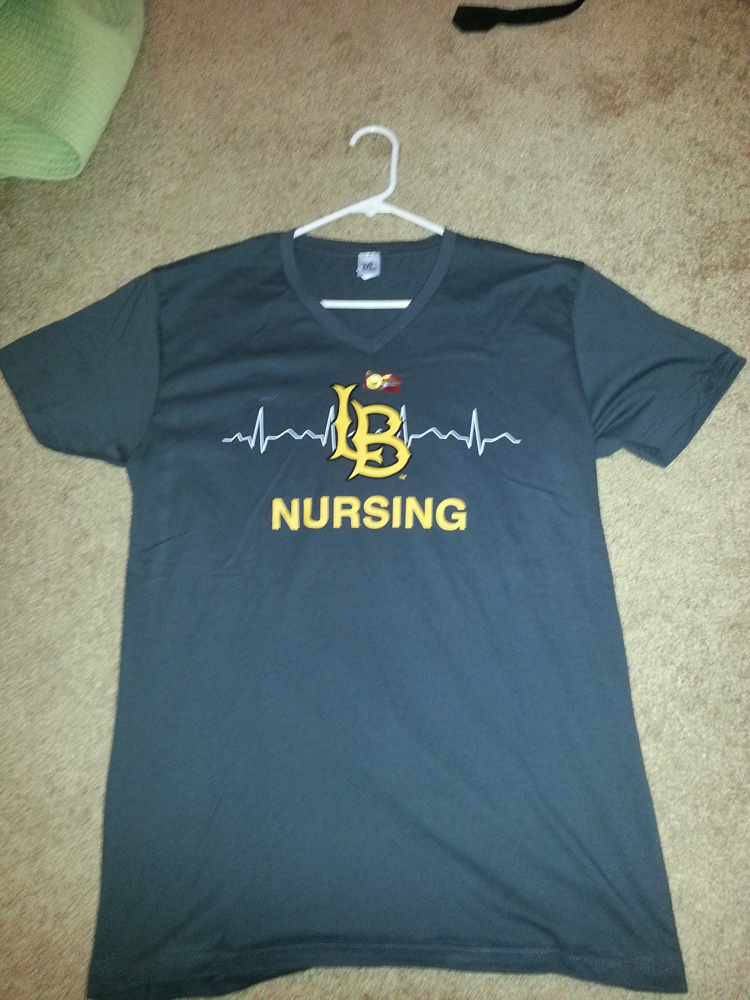

    - Food truck fundraiser?
      - Stephanie will look more into this idea.
  - Legislative Director--- Emily Smith
    - Faculty meeting update
      - Hopefully all Health Trackers UP TO DATE
      - During clinical no long sleeve shirt, watches, and only solid watches are allowed at LBMMC.
      - Change the Nursing Research Class from the end of the nursing program to the beginning of the program.
      - SON got approval to do to the AND to BSN summer program.
      - Possible RN to BSN program online in the future.
      - Incorporate Informatics during clinicals, how technology is very important in our field especially with the electronic charting.
  - Membership Director— Natalie Sustaita
    - If your classmates want to join please direct them to Natalie or if you get membership forms/money from your classmates please give them to Natalie
  - Public Relations Director—Nell Dangcil
    - Send Nell information about your events, so he can post them on Facebook or around the School of Nursing
    - We should be getting the CNSA banner on Monday, January 26, 2015.
    - Nell D. will be starting a new CNSA Instagram!!!
      - CNSA Instagram username: beach_cnsa
Committee Reports
  - Student Support—Andrea Seu
    - Class Reps please announce: Happy Hour
      - Wed, Feb. 4th from 11:30am-1pm
        - Still trying to find a room
          - This first one will most likely be in the courtyard outside the new nursing building by the plastic tables and chairs
    - Class Reps please announce Soroptimist Mixer
      - Tentative date: Wed, Feb. 18th from 11am-1pm
      - Budget: $250 for food and venue
        - Approved!
    - Bowling Mixer
      - Feb. 25th or March 4th (Both Wednesday nights) Due to 1st semester students having nutrition class that evening.
        - New date TBA
      - Budget: $200 for food and venue
  - Mentorship--- Tanya Jilkevorkian
    - Mentorship committee plan for the Spring semester?
    - 3rd semester student would like a new mentor after switching from trimester to semester
      - Anyone interested?
  - Professional Growth and Development—Katie Sidman
    - HOW TO GET A JOB
      - Date: Thursday, February 19th
      - Time: 1700-1800
      - Location: TBA
      - Budget Request: $75 Thank you cards, gift cards, snacks
      - Approved!!!
      - Class reps: Please ask your classmates if they know any alumni or any recent new grads to help for the How To Get a Job Event and email Katie.
    - Resource Day at Los Padrinos Juvenile Hall
      - Not going to work out
    - Robert’s Rules of Order Workshop
      - Pushed back to May or June meeting for the newbies to orient everyone all at once
    - Paramedic Disaster Relief Training
      - Still awaiting response, but don’t lose hope!
    - Army and Airforce Info Session
      - Still awaiting response
  - Community Service—Brooklynn Fay
    - Valentine Card Making for kids in the hospital
      - Before Feb. meeting (Feb 8th)
        - At 3:30-5pm in room 66
        - Class Reps: Please announce to your class if they can DONATE any art supplies that they may have. There will be a collection box in the nursing building.
        - Budget: $30 Art supplies
        - Approved!
    - Ronald McDonald House
      - Trying to get a date in February to make V-day cookies, hopefully before the 14th.
    - Read Across America Class Reps please announce:
      - Monday, March 2nd
      - Hang out and read to kids for an hour or two
      - The Children's Clinic, Serving Children and Their Families (TCC for short). A local non-profit community health center based in Long Beach
    - The Village Street to Home Coin Drive Class Reps please announce
      - Continuous community service event going on
      - Please donate any pocket change
      - Collection bottle in front of Catherine Mullins office
  - Breakthrough to Nursing & Pre-Nursing— Brittni Bohan & Jackie Mckenzie
    - Week of Welcome Class Reps please announce:
      - Wed, Jan 28th and Thurs, Jan 29th
        - 11am-2pm
        - Hippie Lawn
        - Need Volunteers
          - We should sell apparel
  - University Involvement—Bernadette Tomas
    - Bernadette is unable to make meetings next semester due to class schedule, can anyone attend?
      - Meetings are 2nd and 4th Monday from 12:30-1:30 and are mandatory.
      - If anyone can attend, please email Bernadette. You can get credit for honor cords.
- New Business
  - Code Blue with Jay at LBMMC
    - New dates Class Reps please announce:
- Feb 4, Feb 25, March 18, April 8, April 29, May 20, June 10
- Every other Wednesday from 11:30am-2:00pm
- Having problem with not getting enough volunteers and people cancelling last minute
- Will receive event/attendance credit for end of year prize
- Tell Suki Smith if you or your peers are interested
  - CSULB SON Talent Show??? Fun idea for the student body and faculty.
    - Class reps please announce to your classes to see what your classmates think of the idea and get back to us for the next meeting.
  - CSULB CNSA Website Class Reps please announce:
    - http://csulbcnsa.weebly.com

- Old Business
  - New Student Orientation
  - The Village Street to Home Coin Drive
- Adjournment at __6:17pm_
- Next meeting February 8th at 5 pm in Room 66
  - CNSA Valentines card making Feb. 8th at 3:30pm-5pm in Room 66.
  - Meeting after is March 1st at 5 pm

